|  |  |
| --- | --- |
|  | **FPT ACADEMY INTERNATIONAL**  **FPT – APTECH COMPUTER EDUCATION** |

**USER GUIDE**

**TRANSLATE THIS**

|  |  |  |
| --- | --- | --- |
| **Supervisor.** | **Lê Mộng Thúy** | |
| **Batch.** | **T1.2303.M0** | |
| **Group.** | **01** | |
| **Serial No.** | **Student Name** | **Enrollment Number** |
| **1** | **Vũ Minh Tuấn** | **Student1459120** |
| **2** | **Bùi Thị Nhung** | **Student1459130** |
| **3** | **Trương Nguyễn Quang Huy** | **Student1468180** |

**Month 01 Year 2024**

**TABLE OF CONTENTS**

**SYSTEM REQUIREMENT** 2

**APPLICATION INSTALLATION** 2

**OVER VIEW** 4

❖ **MENU** 5

❖ **FOOTER** 5

❖ **THIẾT LẬP** 5

❖ **TỪ ĐIỂN** 8

❖ **DANH SÁCH TỪ** 16

❖ **LUYỆN TẬP** 40

❖ **TỔNG KẾT** 47

❖ **BẢNG ĐIỂM** 51

❖ **BẢNG XẾP HẠNG** 53

# **SYSTEM REQUIREMENT**

*For usage:*

|  |  |  |  |
| --- | --- | --- | --- |
|  | | **Online Mode** | **Offline Mode** |
| **Hardware** | Processor | Intel Core I5 or higher | Intel Core I5 or higher |
| Memory | 8 GB RAM or greater | 8 GB RAM or greater |
| Monitor | Super VGA (1366x768) or higher resolution | Super VGA (1366x768) or higher resolution |
| Modem/ADSL | Internet access is required | None required |
| **Software** | Operation System | Window 10 or higher | Window 10 or higher |
| Software | Java Runtime Environment | Java Runtime Environment |

*For deploying:*

|  |  |  |
| --- | --- | --- |
| **Hardware** | Processor | Intel Core I5 or higher |
| Memory | 8 GB RAM or greater |
| Monitor | Super VGA (1366x768) or higher resolution |
| Modem/ADSL | Internet access is required |
| **Software** | Operation System | Window 10 or higher |
| Software | Simple logging facade |
| ControlsFX |
| SQLite tools |
| Development Software | * Microsoft Windows 10 * SQLite Studio * NetBean * Scene Builder |
| Technology | * Java * JavaFX * CSS * SQLite |

# **APPLICATION INSTALLATION**

• This document was created to guide users to use the dictionary application – Translate This effectively. It is advisable that users should read this material before starting to use this site in practice.

• To run Translate This apllication, users can follow the following options:

1. **Direct access via our project github link:**

https://github.com/Moxxi123/Moxxi123-T1.2303.M0-Project2-Group_1-TranslateThis

1. **Download our project from github by following these steps:**

**Step 1:** Visit our group project github repository address at:

https://github.com/Moxxi123/Moxxi123-T1.2303.M0-Project2-Group_1-TranslateThis

**Step 2:** In the < > Code tab, click Download as ZIP (follow the instructions image bellow).

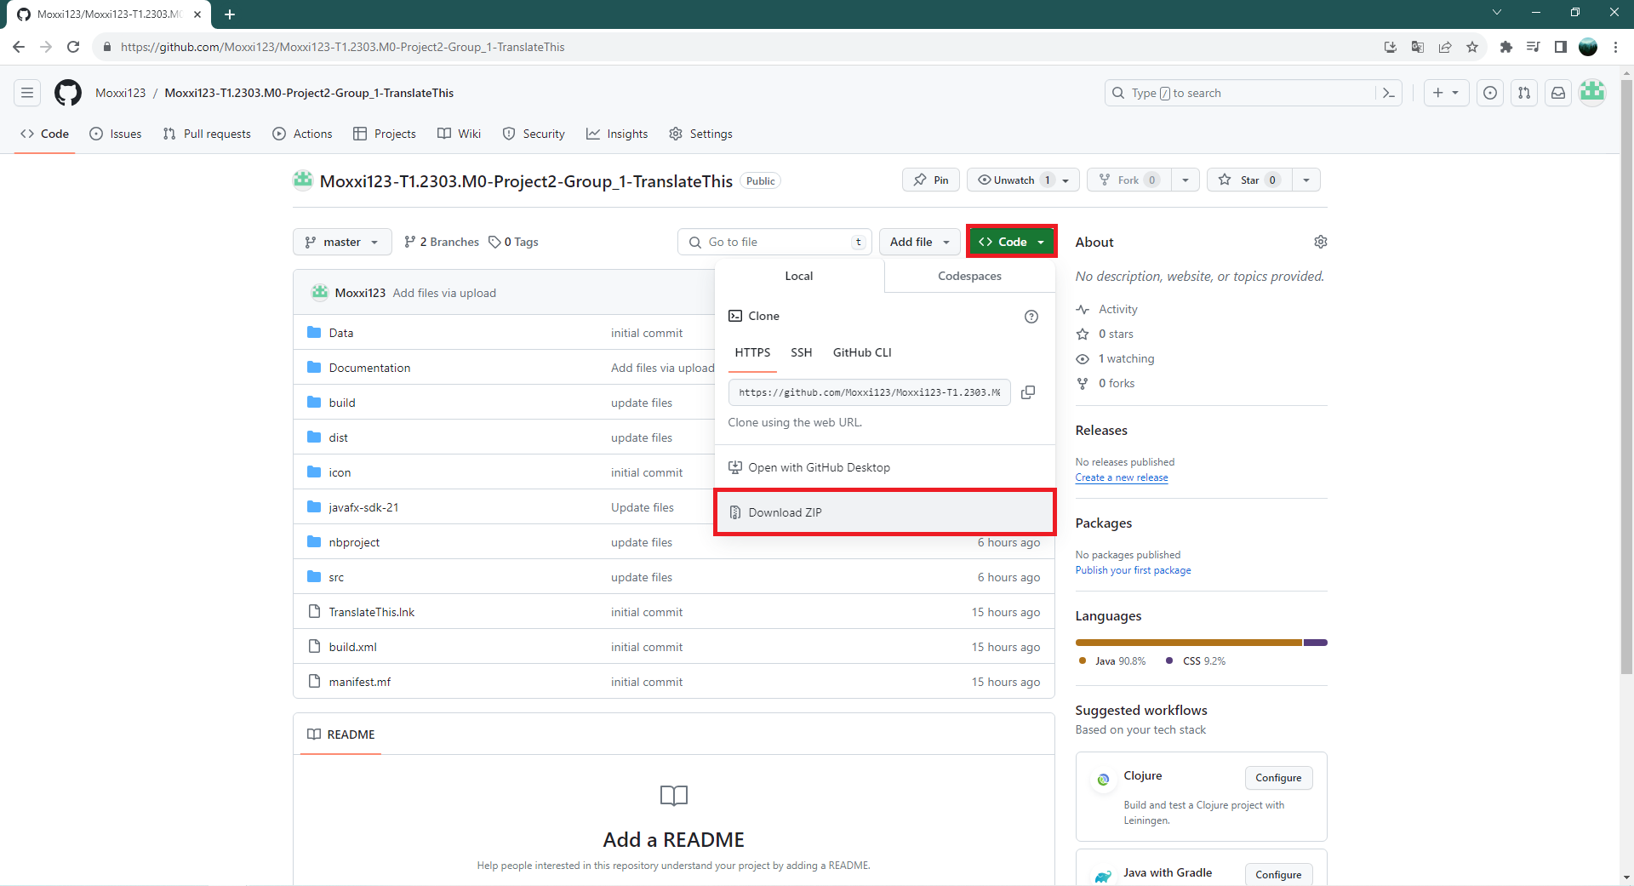

**Step 3:** Extract file rar: Moxxi123-T1.2303.M0-Project2-Group_1-TranslateThis-master.

**Step 4:** Open Moxxi123-T1.2303.M0-Project2-Group_1-TranslateThis-master folder.

**Step 5:** Open dist folder.

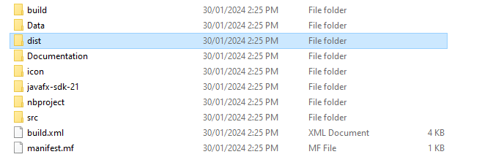

**Step 6:** Click on the “run.bat” file to start the “Translate This” application.

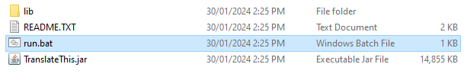

# **OVER VIEW**

There are a total of 10 pages including 3 main window (“Từ điển”, “Danh sách từ”, “Luyện tập”) and 7 sub-window (Anh-Viet Dictionary, Anh-Anh Dictionary, Add input window, Edit input window, “Bảng điểm”, “Tổng kết”, “Xếp hạng”) in the Translate This application.

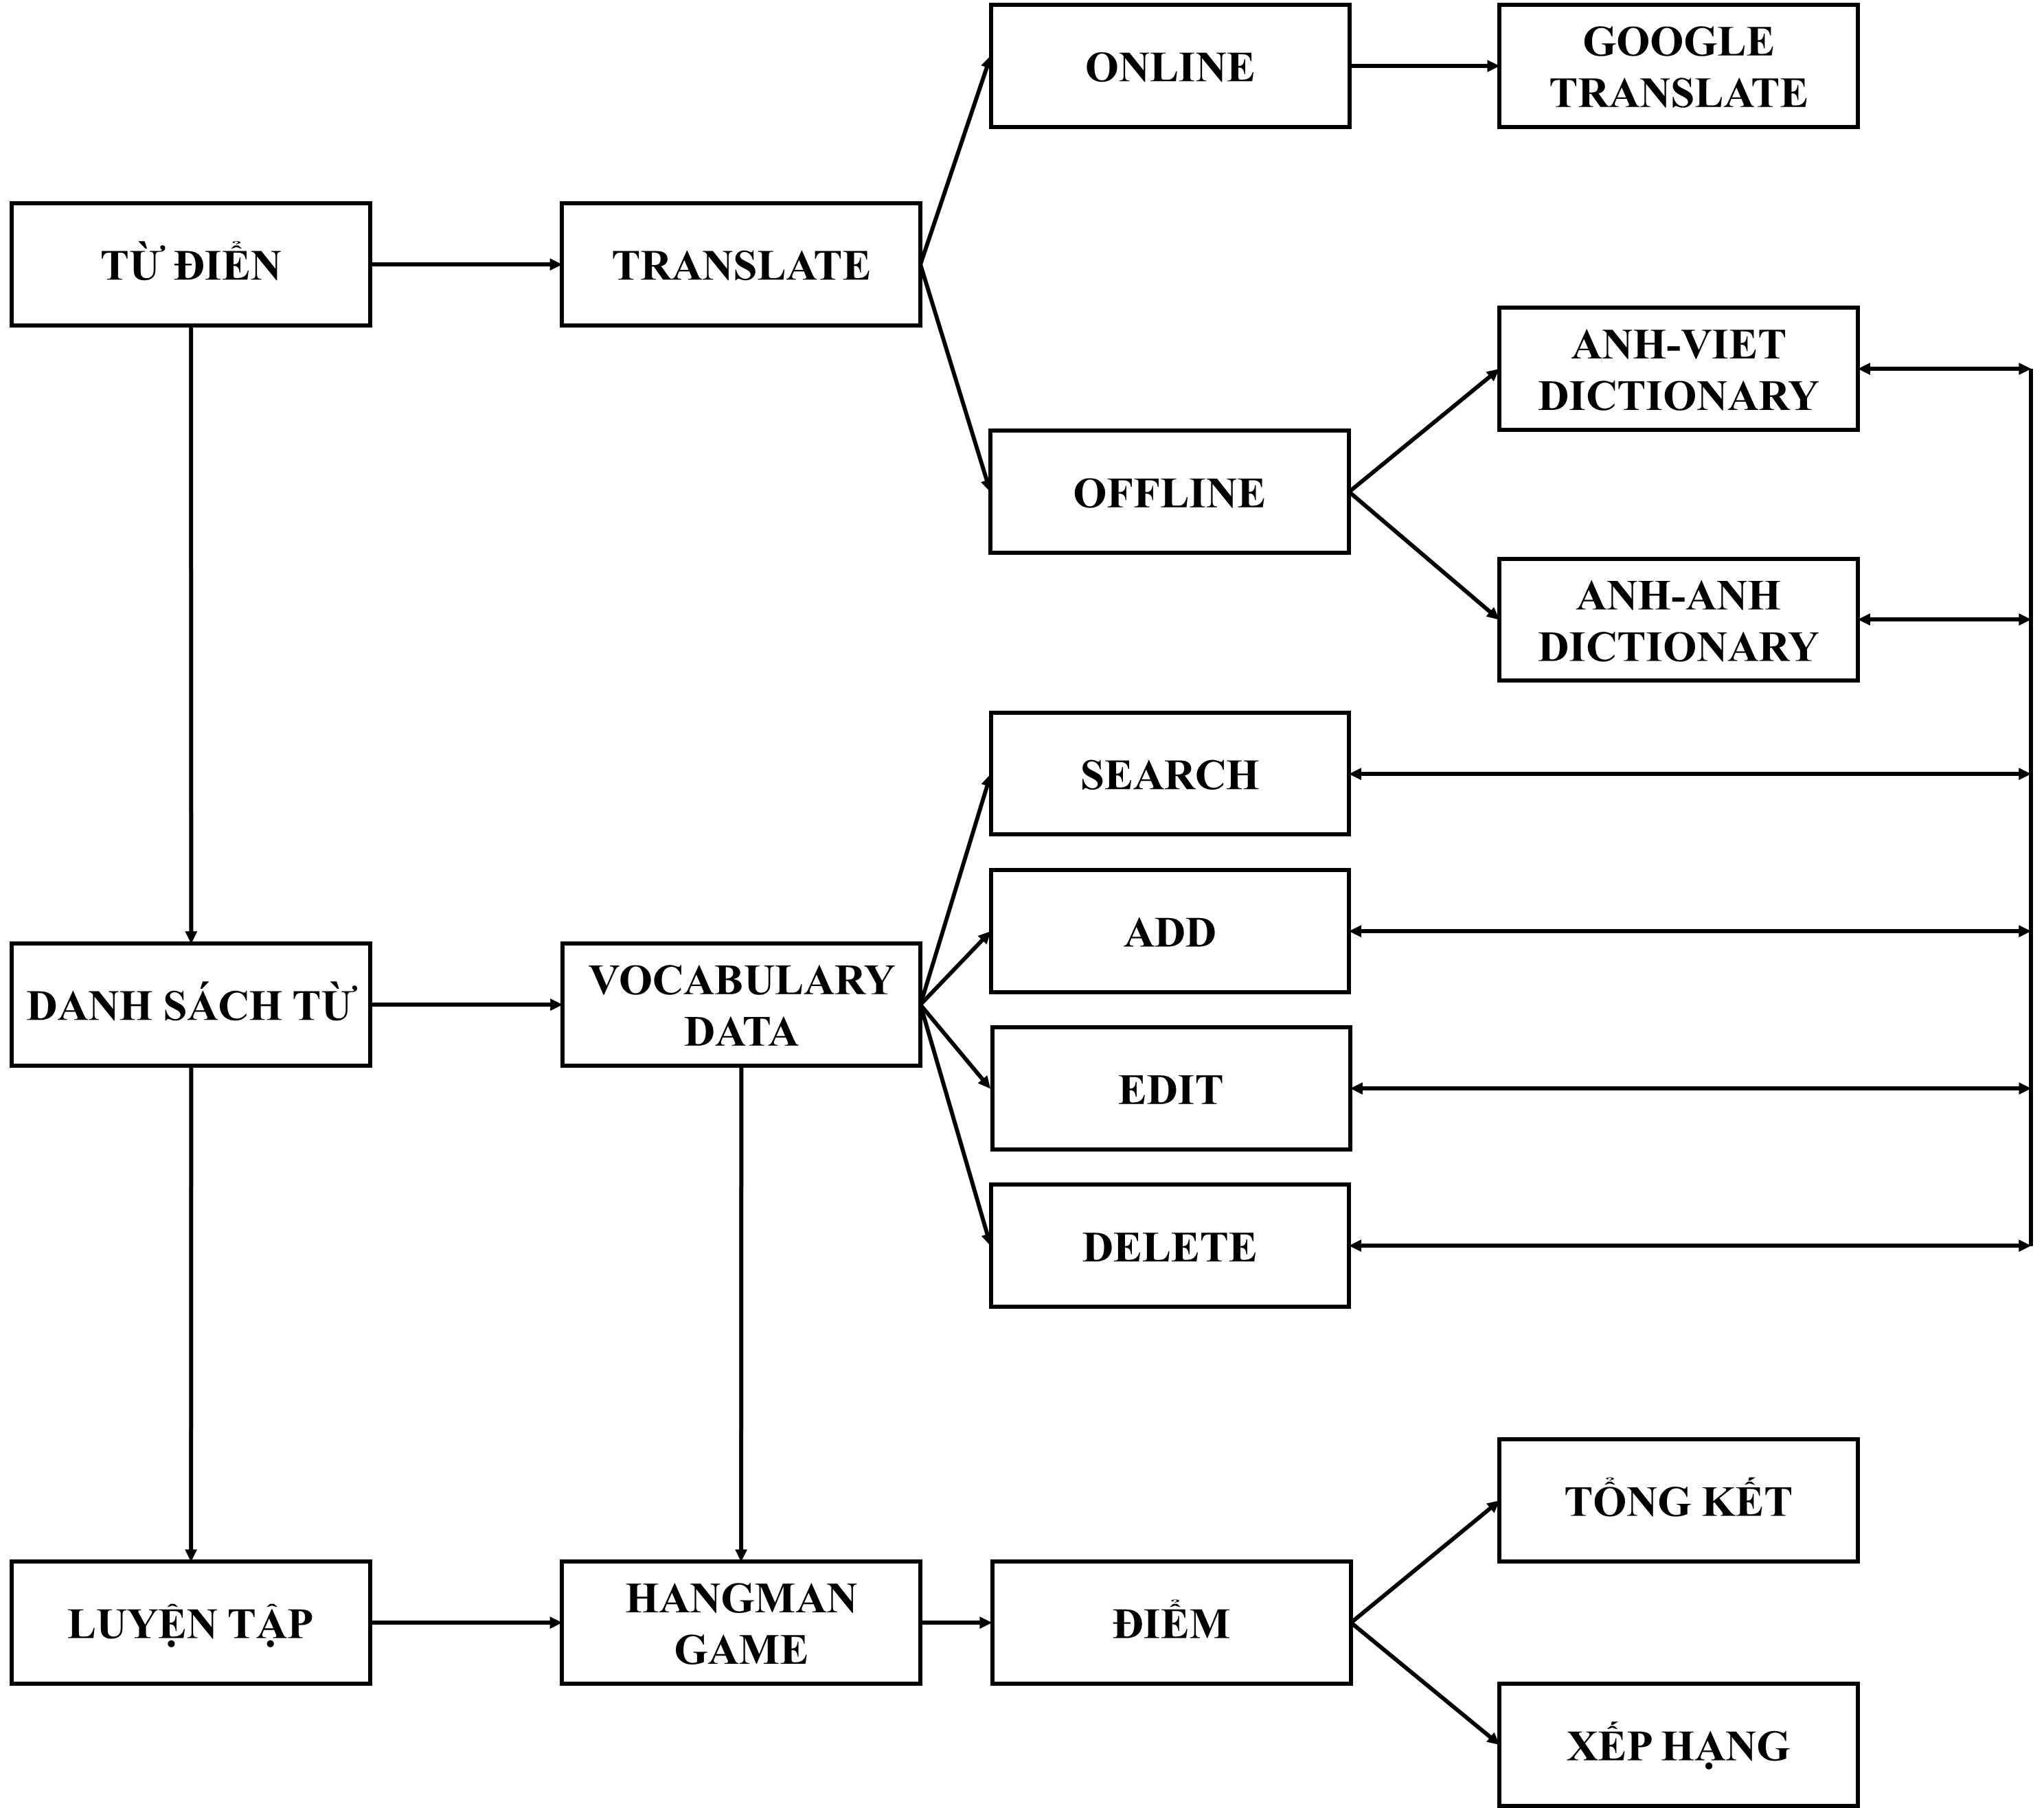

## **MENU**

The menu is on top of every main window. It contains Navigation Menu for all the main application functions in the Translate This.

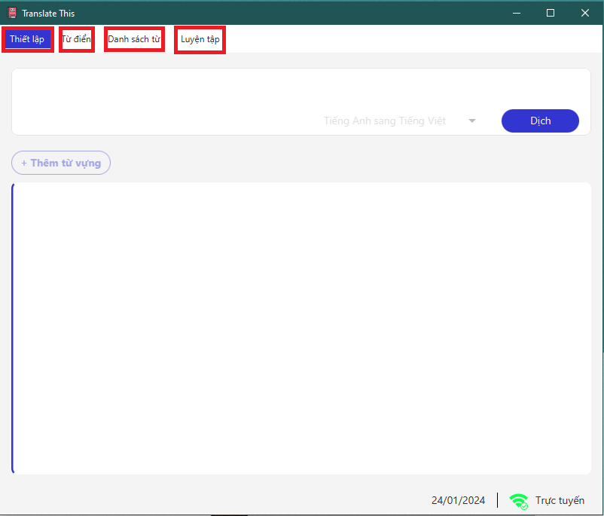

## **FOOTER**

The footer is at the bottom of every main windows. It contains information about current date and the connection status to Google translate URL.

Application will auto check for connection to Google translate URL. If it can”t connect, then it will switch back to offline mode.

**Case 1**: The application connects successfully to Google Translate URL:



**Case 2:** The application can”t connect to Google Translate URL:

The application will pop up a restriction message in offline mode.



## **THIẾT LẬP**

1. Toogle Switch

The toggle switch can be used to switch from online to offline mode. Note that online mode can only be activated when the application can connect to the Google translate URL. Otherwise, the application will automatically switch back to an offline state.

**Case 1**: Online mode:

User can search vocabulary information through Google Translate

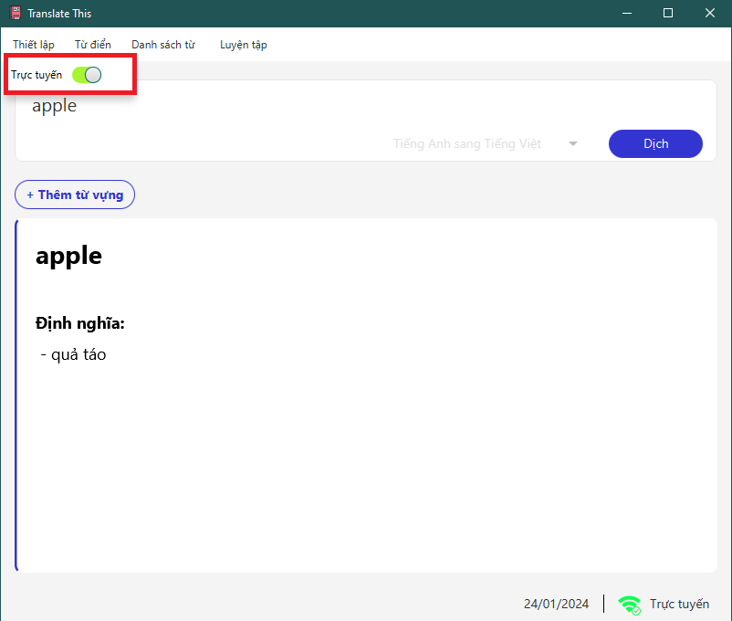

**Case 2**: Offline mode:

Users can search for vocabulary information through offline dictionaries in the system: English-Vietnamese dictionary and English dictionary.

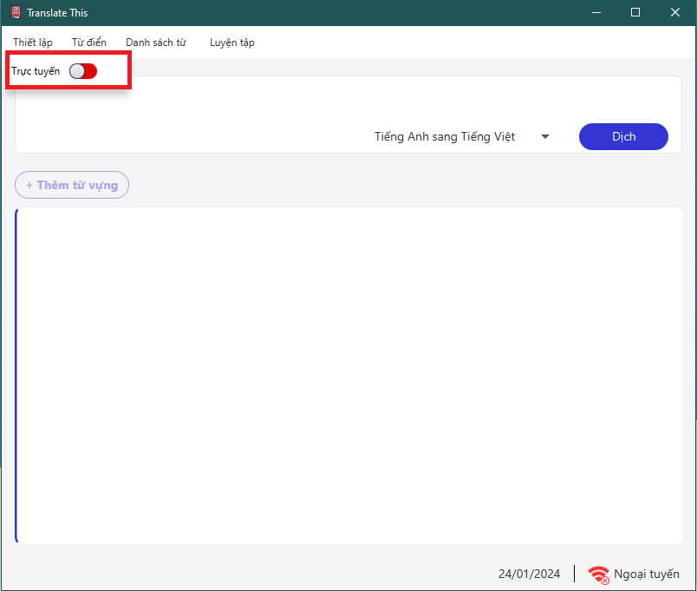

Application will display restriction alert when using online mode

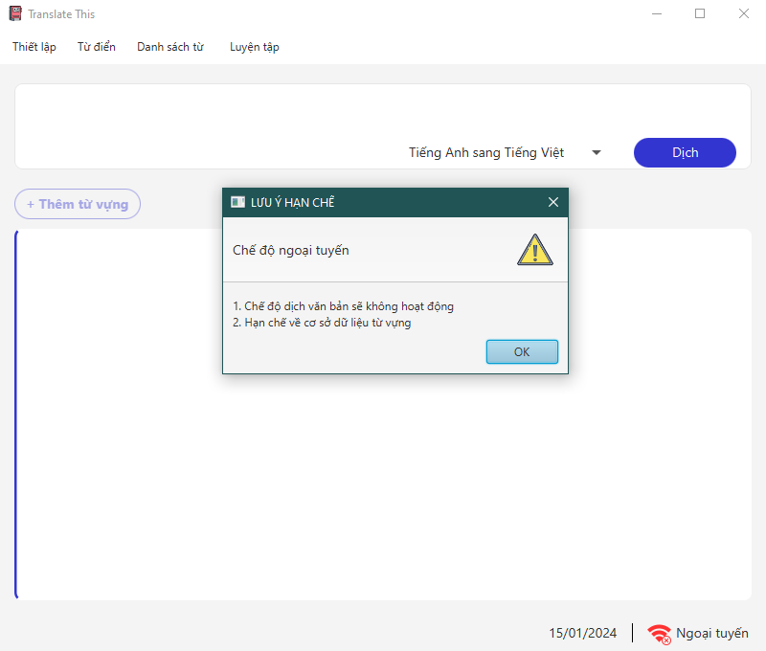

## **TỪ ĐIỂN**

1. Input text field

User can enter word into the text field to translate. The text field will validate the data input and give suggestions if the word is in the database. If the data isn”t suitable, the program will display errors.

**Case 1:** The data input matches the pattern:

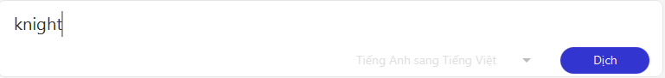

**Case 2:** The data input does not match the pattern:

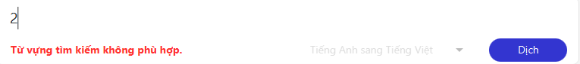

**Case 3:** The data input exceeds the limit of 30 characters:

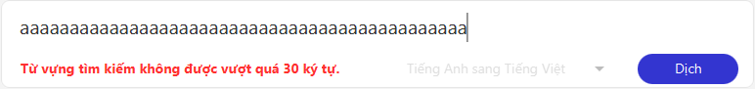

**Case 4:** If the input data is in the database, the application will display suggestions:

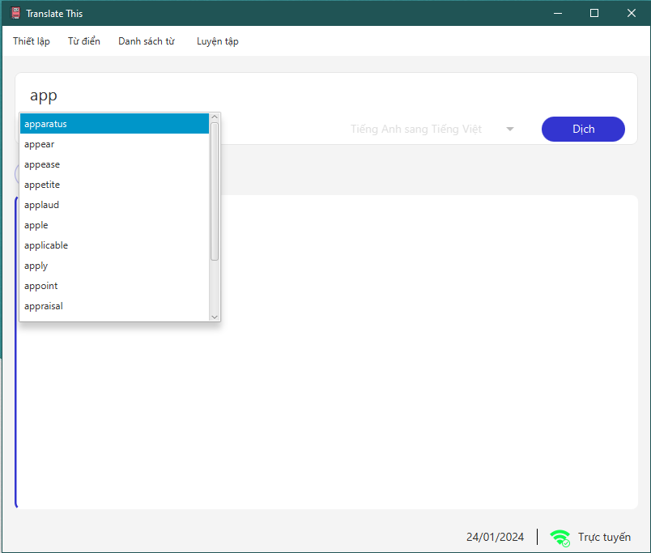

1. “Dịch” button

When the user selects the translate button, the program first checks if the text field contains data. If the field is empty or an input error occurs, the program will not display any translation. Once it confirms that the text field has valid data, the program will translate the provided word using the suitable dictionary type: Google Translate in online mode and a dictionary system in offline mode.

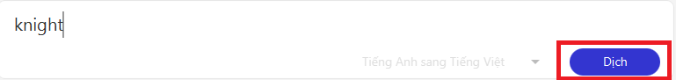

**Case 1:** Display translation in online mode:

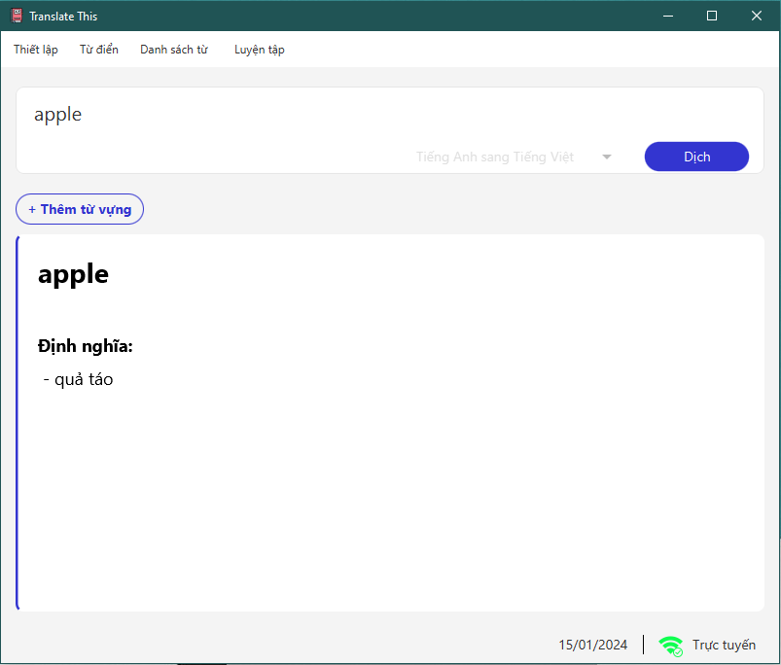

**Case 2:** Display translation in offline mode:

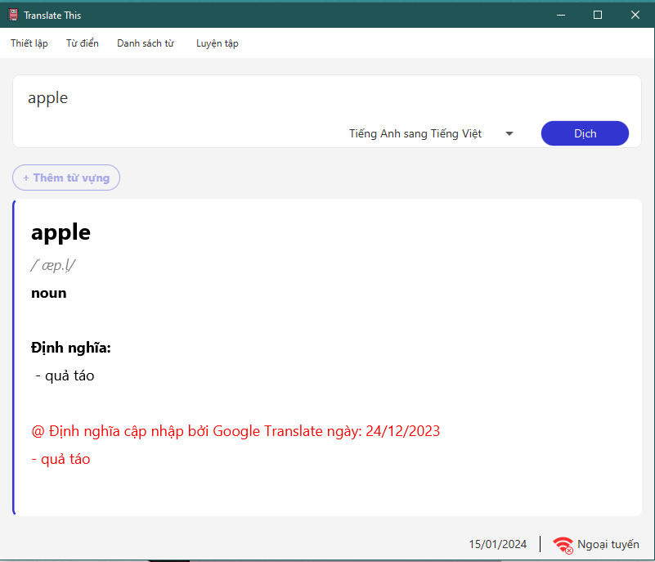

1. Language selection

In offline mode, the application allows users to choose between English-to-Vietnamese and English-to-English translation options. It then displays the translation based on the selected language pair.

**Case 1:** Display English to Vietnamese translation:



**Case 2:** Display English to English translation:

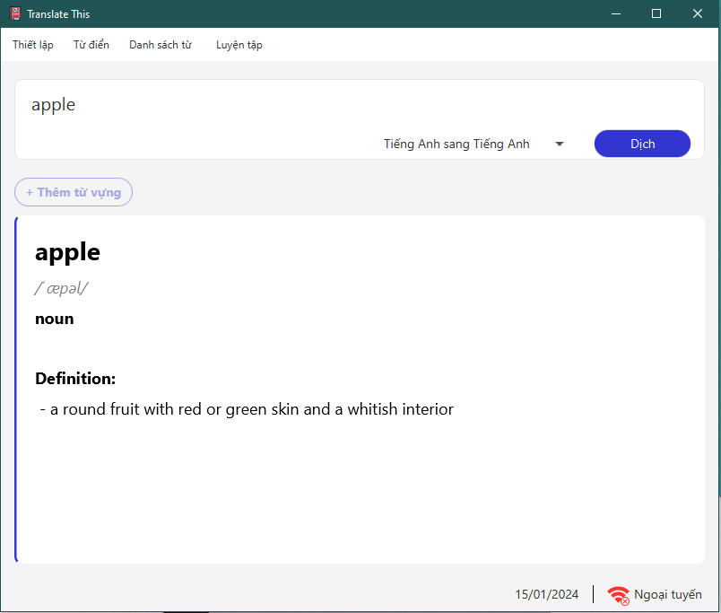

1. “Thêm từ vựng” button

When the user clicks the “Thêm từ vựng” button, the program first verifies whether the text field contains any data. If the field is empty, the button is disabled. If the text field has valid data, the program checks whether the word already exists in the database. If the word does not exist, the button functions as an insert button, adding the new vocabulary and its definition to the database. However, if the word is already in the database, the program compares the current definition with the existing one. If they are identical, an error is displayed, and the update of the definition is prevented. If the definitions differ, the program allows the definition to be updated.

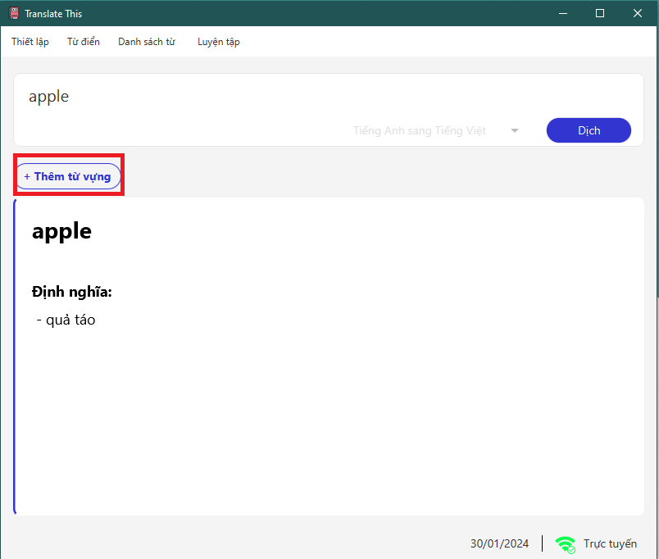

**Case 1:** The program disables the “Thêm từ vựng” button when the text field does not contain any data.

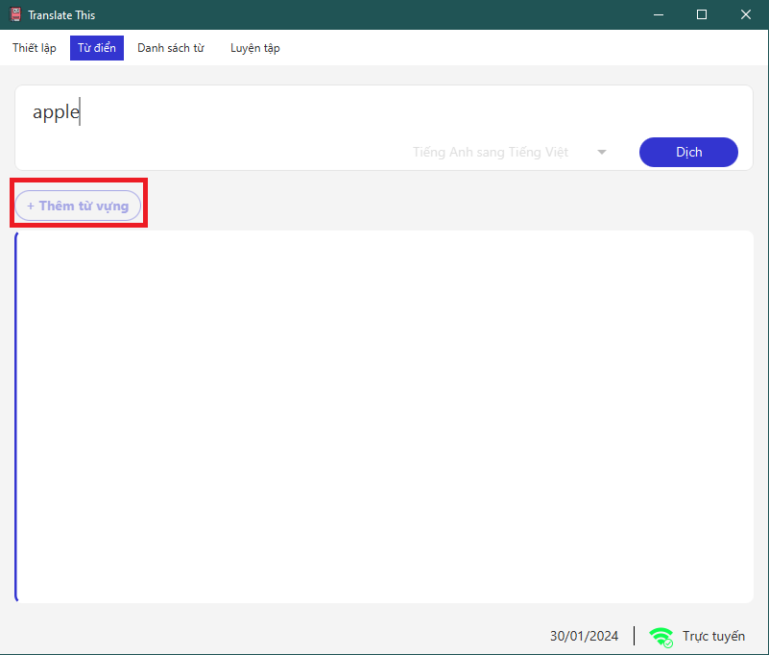

**Case 2:** The word does not exist in data.

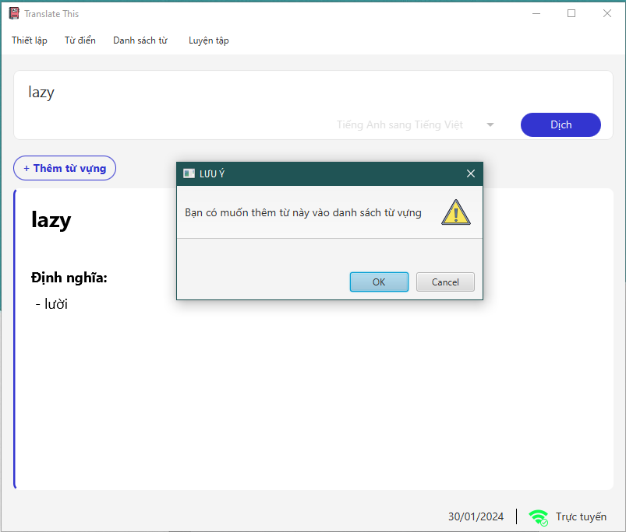

**Case 3:** The word exists in data.

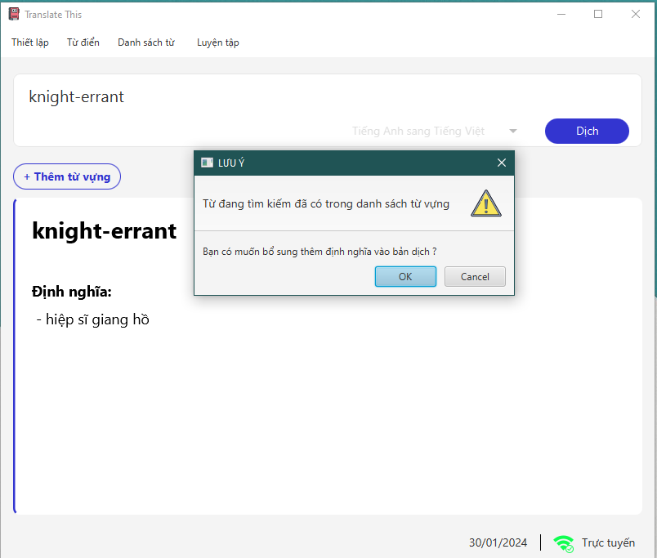

**Case 4:** The updated definition is already present in the database.

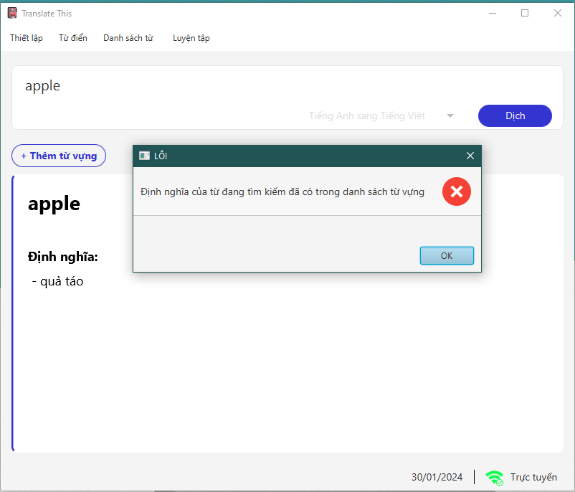

## **DANH SÁCH TỪ**

When clicking on the “Danh sách từ”, the page will display a table containing vocabulary items retrieved from the database, as well as newly added words by the user. The interface of the page will present detailed information about each word in the vocabulary list.

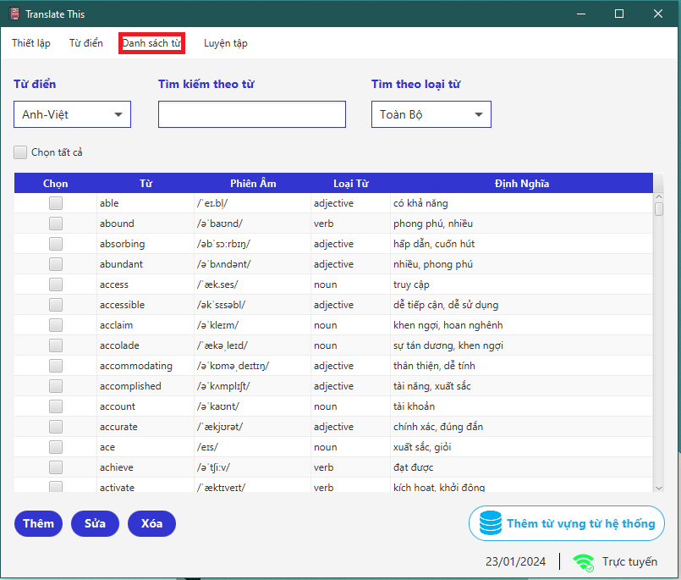

1. “Từ Điển” option

When selecting the Dictionary, there are two tables available: Anh-Việt and Anh-Anh, with the Anh-Việt table set as the default.

**Case 1 :** When selecting the English-English dictionary, the English-English word list will be displayed.

**Case 2 :** When choosing the English-Vietnamese dictionary, the English-Vietnamese word list will be displayed.

1. “Tìm kiếm theo từ” search

When a search term is entered, the list will display the corresponding vocabulary

**Case 1** : When search term not found

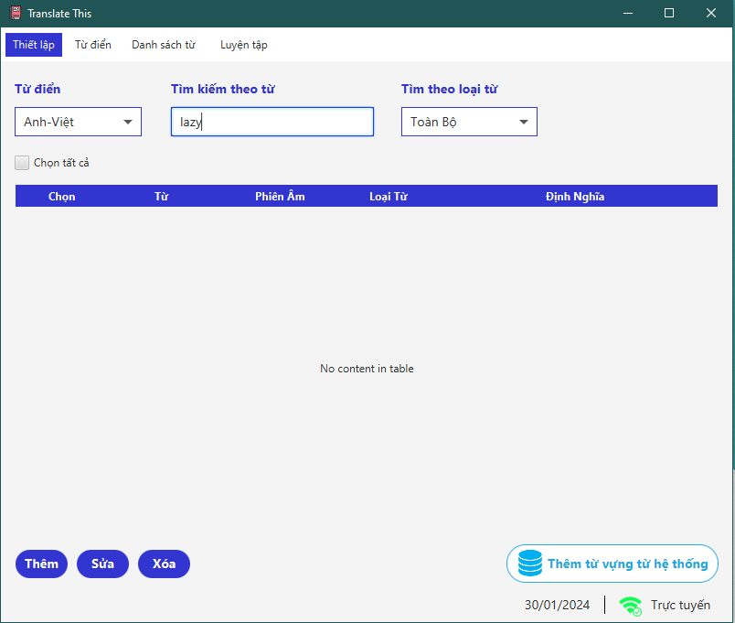

1. “Tìm theo loại từ” option

The vocabulary type option box enables filtering based on word properties like nouns, verbs, adjectives, and adverbs. If the word to be filtered is not yet categorized, it can be filtered using the “Uncategorized” option.

**Case 1** : When selecting the word type "Toàn bộ"

1. **Case 2** : When selecting the word type "Danh từ"

**Case 3** : When selecting the word type "Động từ"

**Case 4** : When selecting the word type "Tính từ"

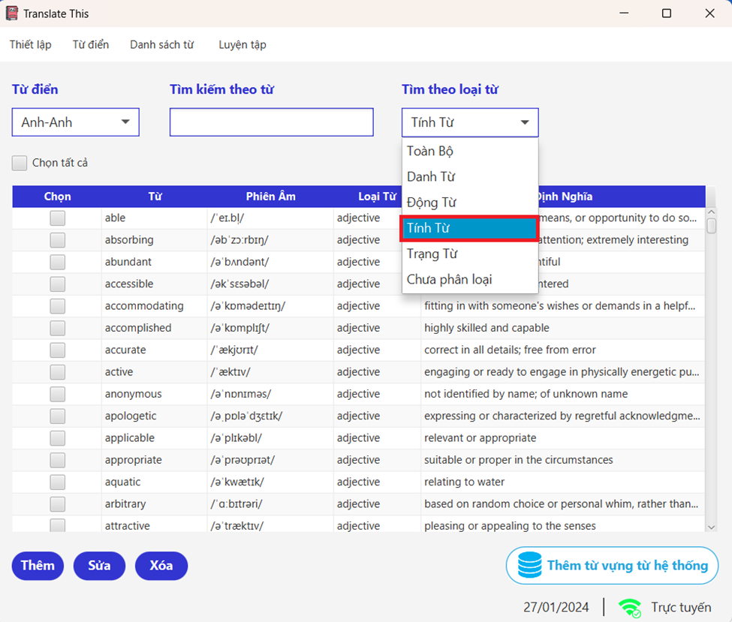

**Case 5** : When selecting the word type "Trạng từ"

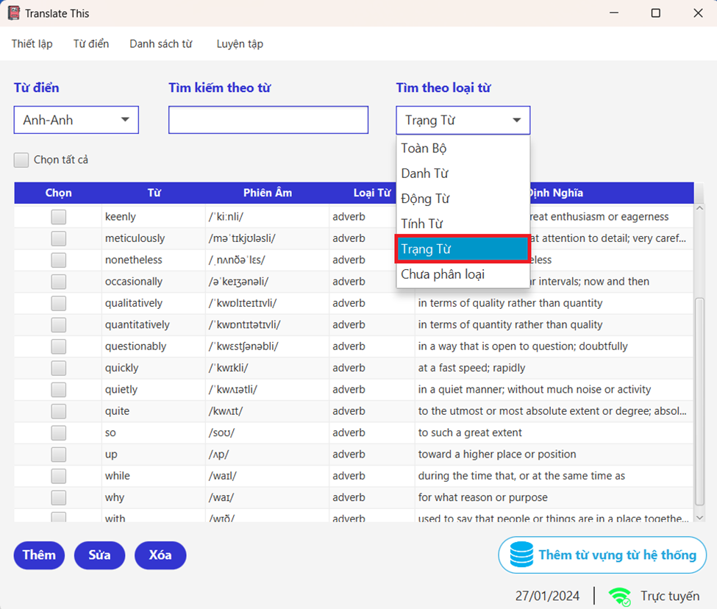

**Case 5** : When selecting the word type "Chưa phân loại"

**Case 6** : When there are no vocabularies matching the type filter

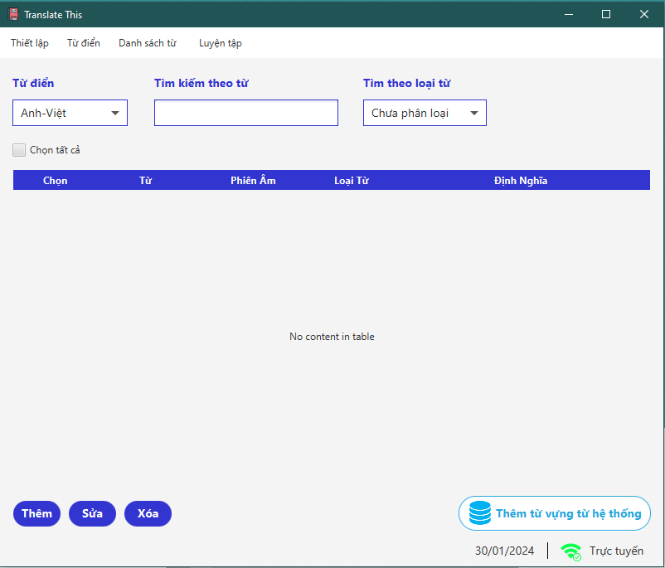

1. “Chọn tất cả” select All

When clicking "Chọn tất cả" all checkboxes will be chosen, or you can select a specific number of checkboxes as desired if you want to edit or remove words from the list.

**Case 1** : Select all

**Case 2** : Unselect all

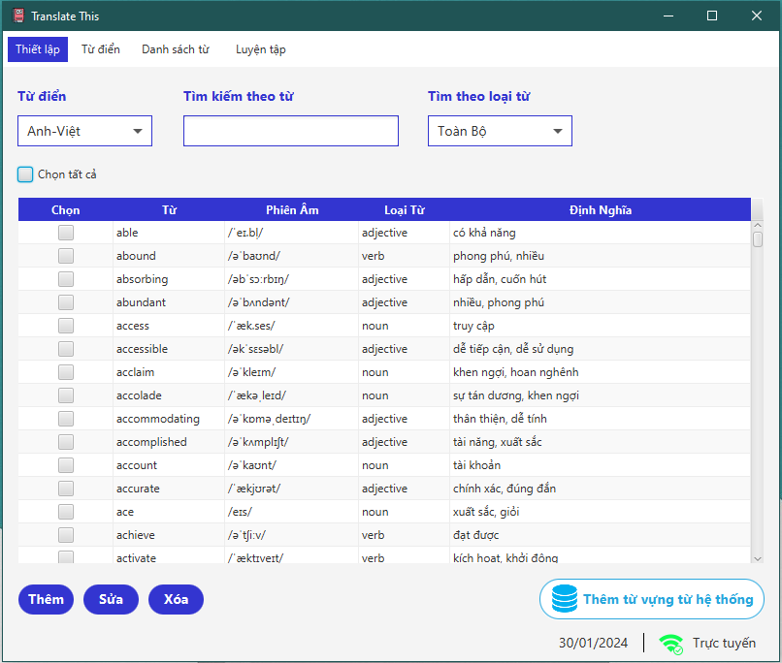

**Case 3** : Select specific checkboxes

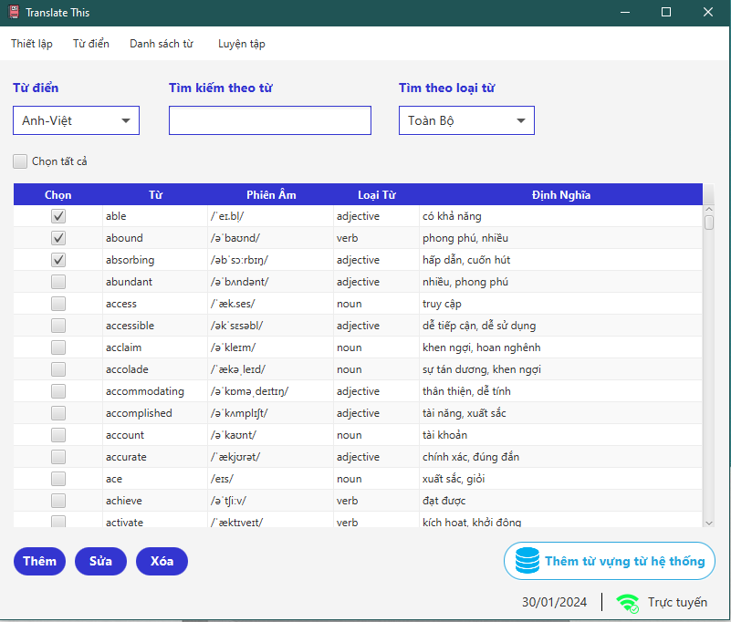

1. “Thêm” button

When the “Thêm” button is clicked, a new window from the “Thêm” page appears, where users can input information to add new vocabulary. The application checks the inputs for validity. If any input is invalid, the submit button is disabled. However, if all inputs are valid, the user can then submit the new vocabulary.

**Case 1 :** The vocabulary, pronunciation, and word definition fields must not be left empty.

* Vocabulary is not allowed to be left blank.

* Pronunciation should not be left blank.

* Definition must not be left blank.

**Case 2 :** The vocabulary already exists in the data

**Case 3 :** The length of the vocabulary exceeds 30 characters

**Case 4 :** The vocabulary and pronunciation are in an incorrect format

* The vocabulary input contains invalid characters.

* The pronunciation is in the incorrect format.

1. “Sửa” button.

When the “Sửa” button is clicked, a new window from the “Sửa” page appears, where users can input information to edit current vocabulary. The application first checks the number of selected words. If more than one word is selected, or in the case of no word being selected, an error message is displayed. It then continues to check the inputs for validity. If any input is invalid, the submit button becomes disabled. However, if all inputs are valid, the user can submit the updated information for the vocabulary.

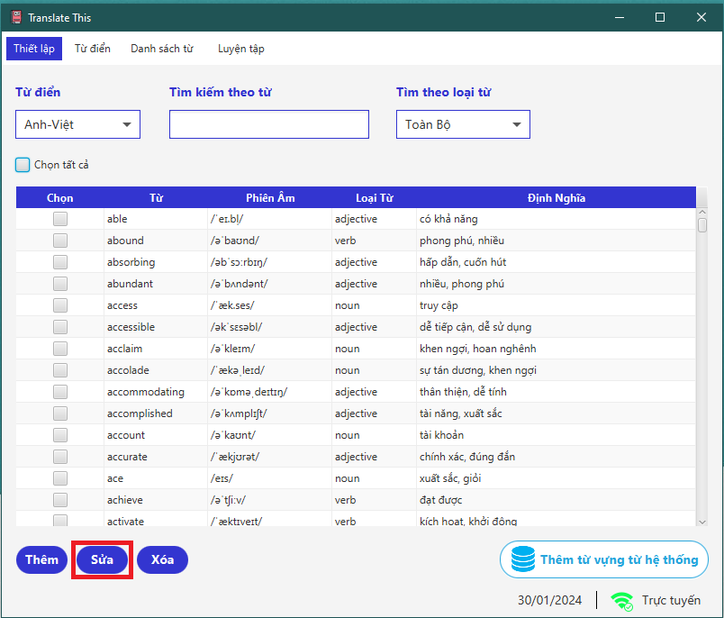

**Case 1 :** No vocabulary is selected

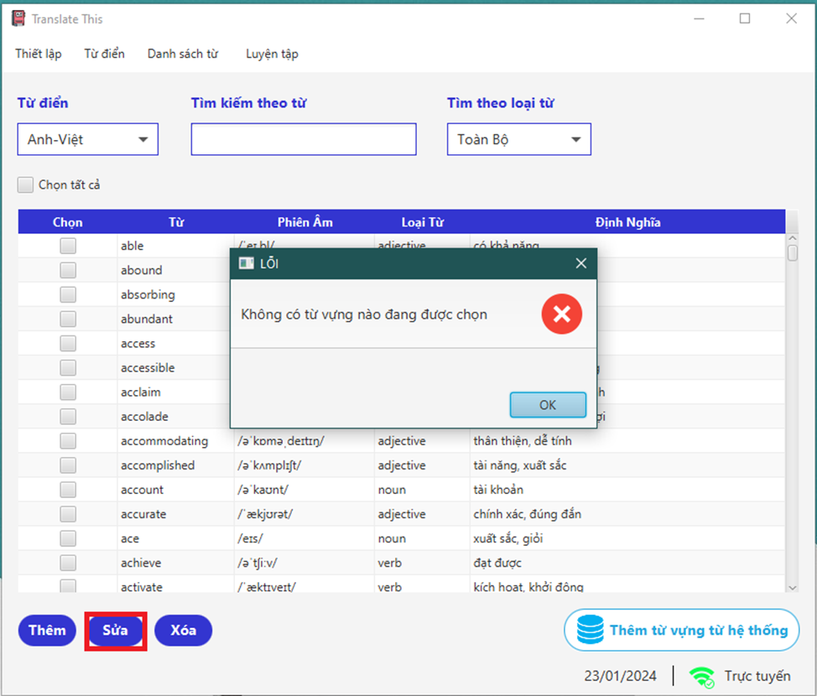

**Case 2 :** More than one vocabulary item is selected

**Case 3 :** The vocabulary, pronunciation, and word definition fields must not be left empty.

* Vocabulary is not allowed to be left blank.

* Pronunciation should not be left blank.

* Definition must not be left blank.

**Case 4 :** The vocabulary already exists in the data

**Case 5 :** The length of the vocabulary exceeds 30 characters

**Case 6 :** The vocabulary and pronunciation are in an incorrect format

* The vocabulary input contains invalid characters.

* The pronunciation is in the incorrect format.

1. “Xóa” button

When the “Xóa” button is clicked, the application checks the number of selected words. If no word is selected, an error message is displayed. Otherwise, the selected words will be deleted from the database.

**Case 1 :** No vocabulary is selected

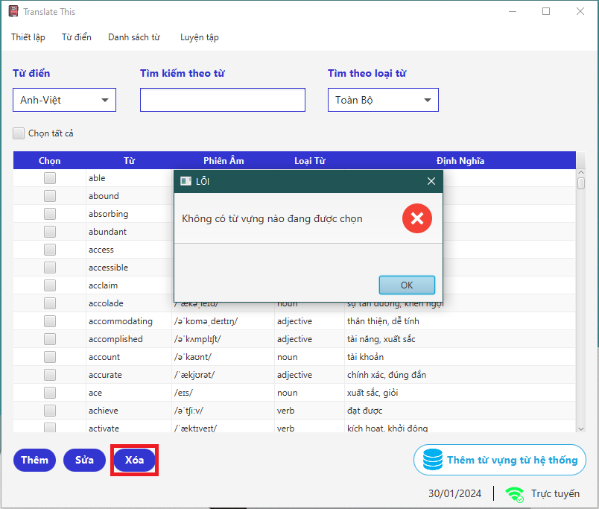

1. “Thêm từ vựng từ hệ thống” button

When the “Thêm từ vựng từ hệ thống” button is clicked, the application checks the number of words that do not exist in the data and inserts them. If all words already exist, the application will do nothing. Otherwise, it will add the non-duplicate words into the data.

## **LUYỆN TẬP**

When clicking on the “Luyện tập”, the page will display the interface of the hangman game. In this variation of Hangman, players attempt to guess 20 hidden words by suggesting letters, with each incorrect guess costing them one of their three total turns; the game session ends either when the player correctly guesses all the letters or loses all their turns.

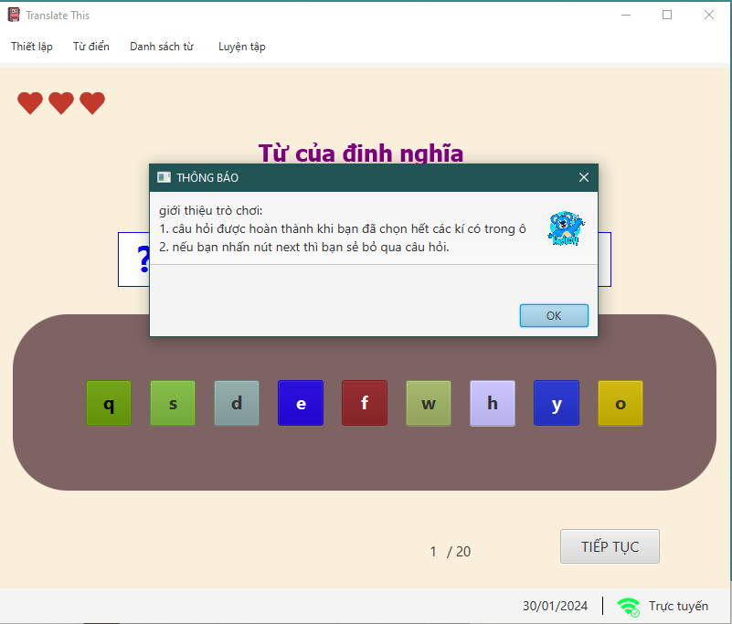

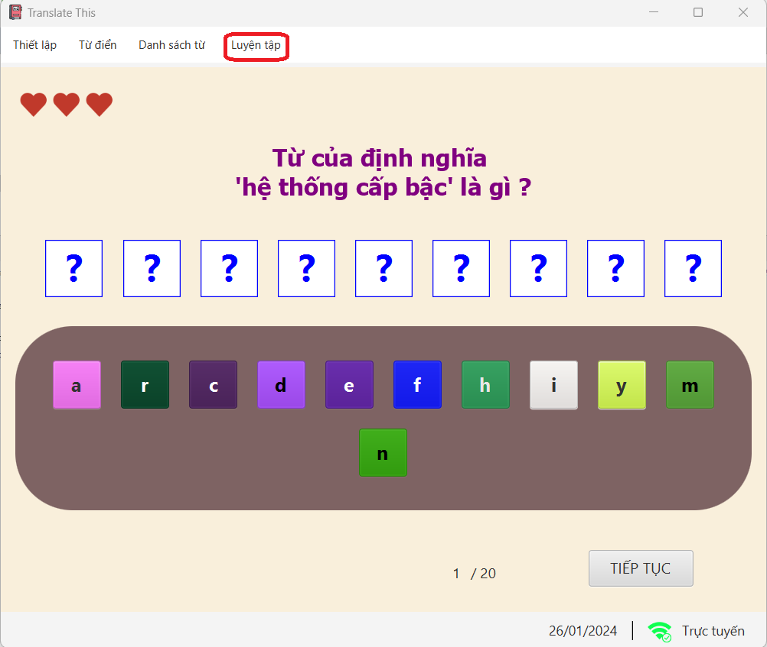

1. Letter selection panel

Players can start the game by selecting random words displayed on the screen one by one to guess the word.

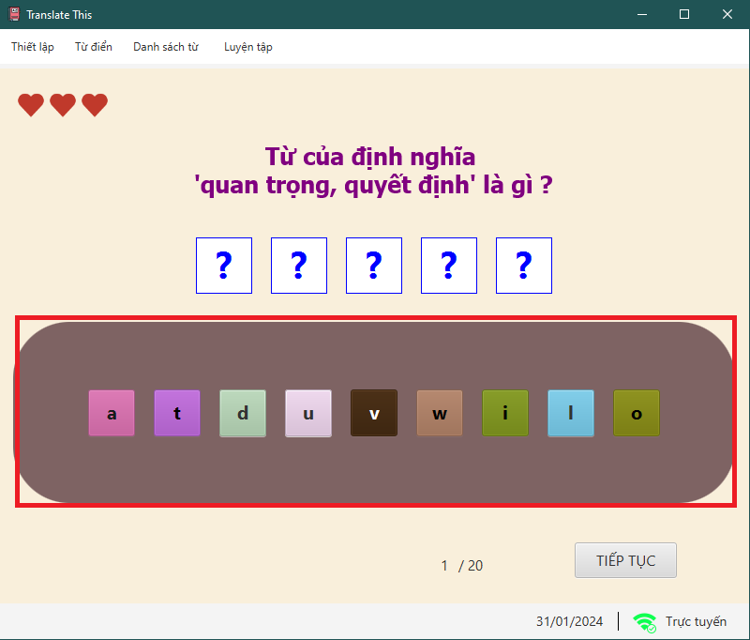

**Case 1 :** Guess correctly

If the guess is correct, the guessed letter will be displayed on the screen and simultaneously hidden from future selections.

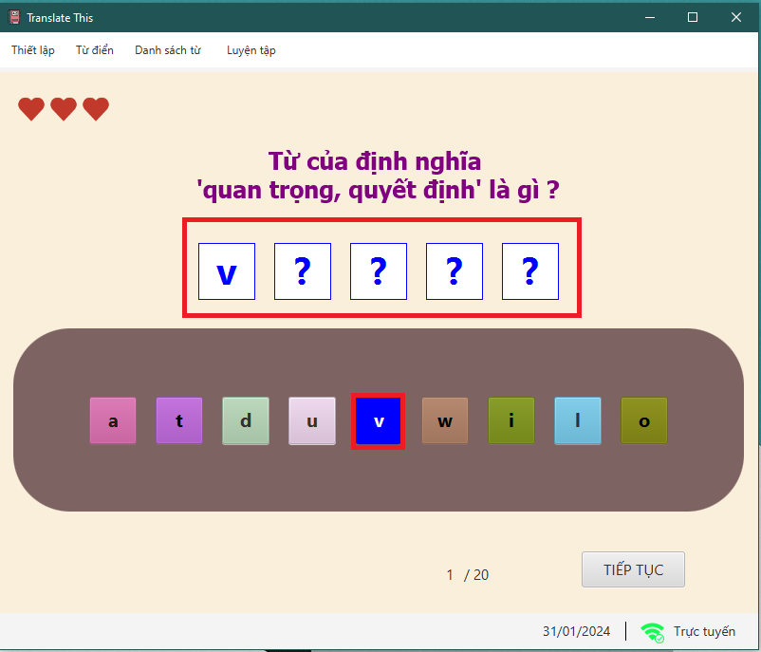

**Case 2 :** Guess wrong

If the guess is incorrect, the guessed letter will not be displayed on the screen; instead, the player loses 1 point and a turn. After a wrong guess, the letter will also be hidden from future selections.

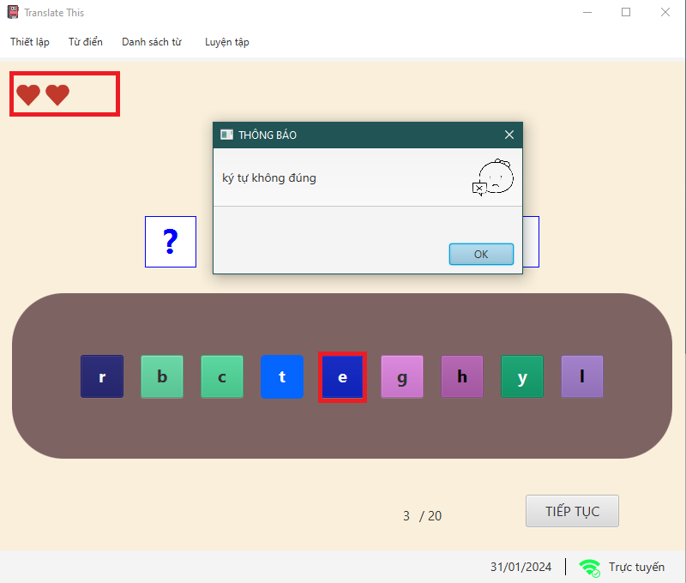

**Case 3 :** Guess wrong 3 times

If a player guesses incorrectly three times, they lose all their turns, leading to the end of the game session. The application will then disable the letter-guessing function to prevent the player from continuing to play.

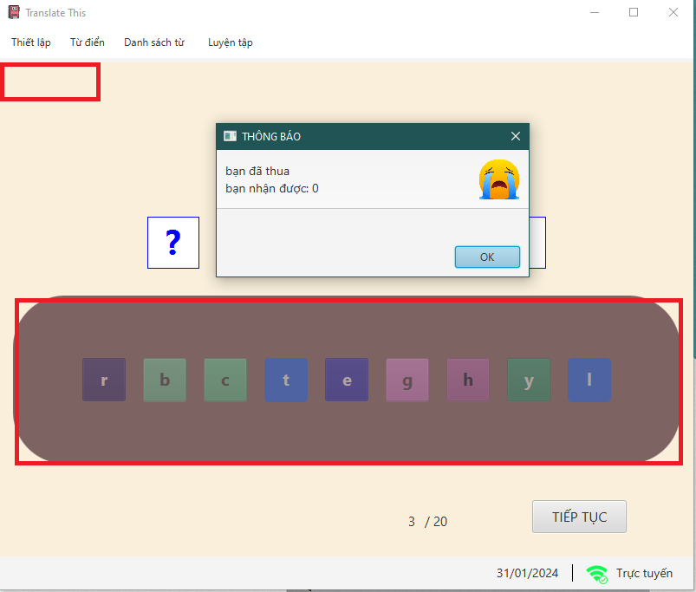

**Case 4 :** Guess all letters correctly

If the player guesses all letters correctly, they successfully complete the word, resulting in a win for the game session. Subsequently, the application will disable the letter-guessing function to prevent the player from continuing to play.

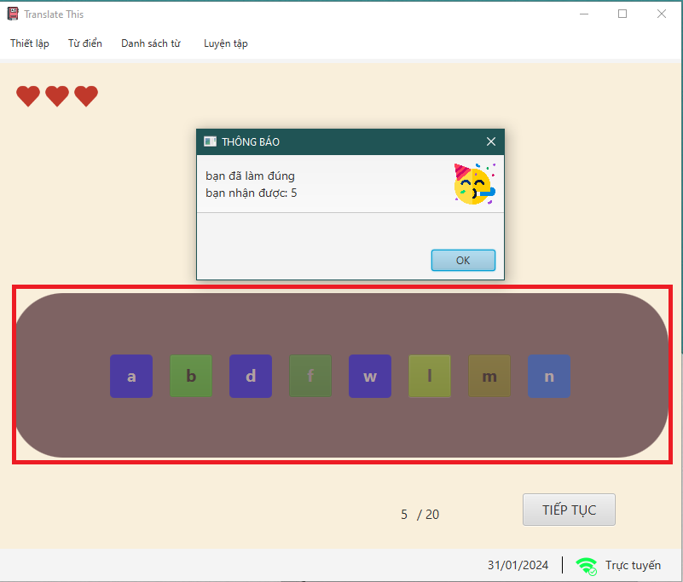

1. “Tiếp tục” button

When the “Xóa” button is clicked, the application checks whether the question has been completed. If completed, it updates the player”s score for the current question and moves to the next one. If not completed, the player”s score for the current question is set to zero, and the application proceeds to the next question. In case the player has answered all 20 questions clicking the continue button will lead them to the summary page.

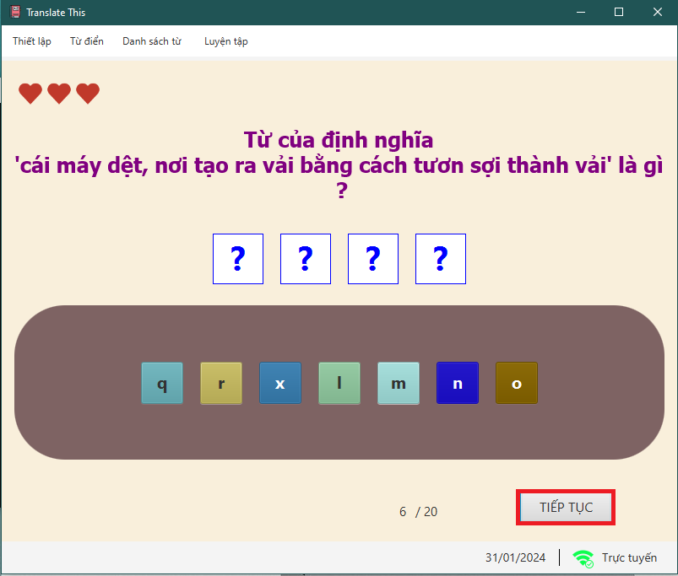

## **TỔNG KẾT**

The detail summary page is designed to display the total score, as well as the questions, answers, and individual scores for each question from the game session.

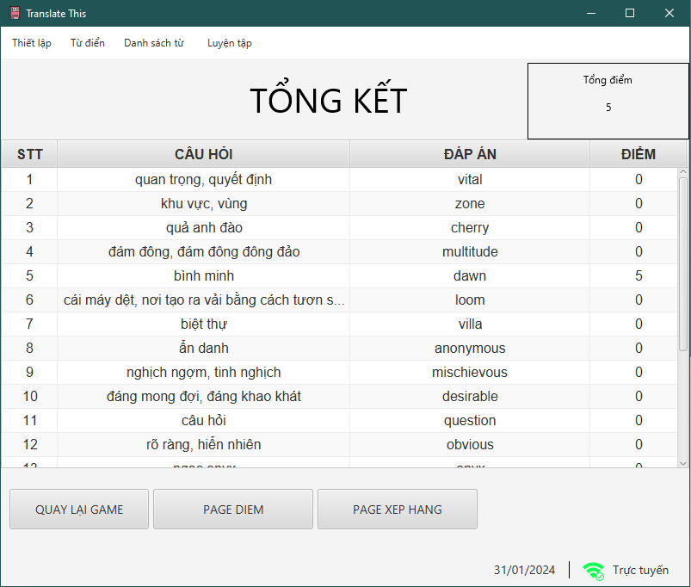

1. “Quay lại game” button

When the “Quay lại game” button is clicked, the application restarts the hangman game from the beginning.



1. “Page điểm” button

When the “Page điểm” button is clicked, the application will open a summary page that displays the total score along with the date and time when the game session was played.



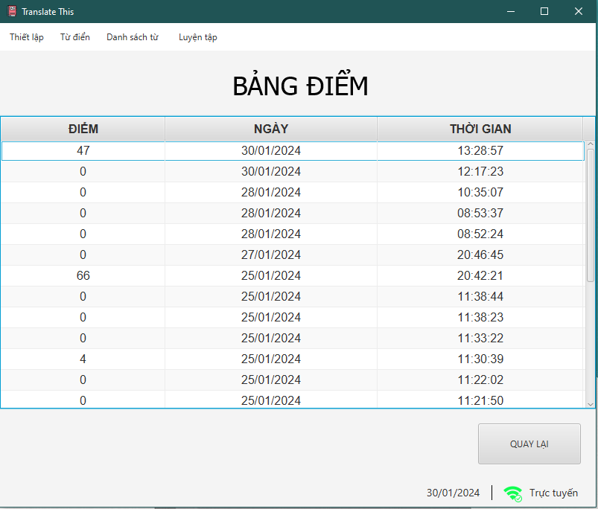

1. “Page xếp hạng” button

When the "Page điểm" button is clicked, the application will open a ranking page that displays the top 10 players with the highest scores.



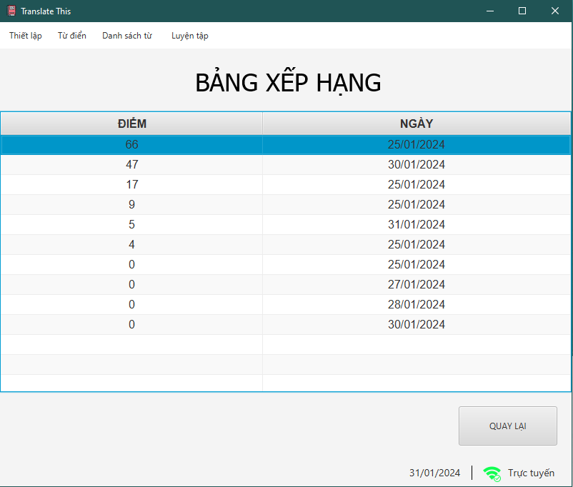

1. Filter table

The "Filter table" feature allows users to apply specific criteria to sort or narrow down the data displayed in a table. This can include options like filtering by score range, date, player name, or other relevant categories, making it easier to find and analyze specific data points within the table.

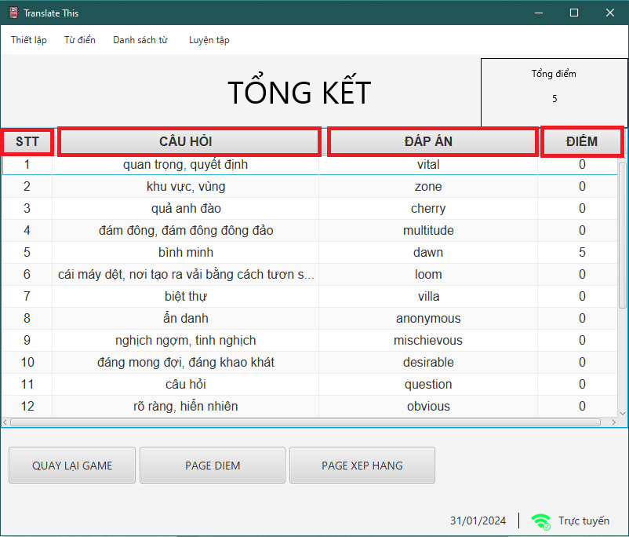

## **BẢNG ĐIỂM**

The summary page is designed to display the total score along with the date and time when the game session was played.

1. Filter table

The "Filter table" feature allows users to apply specific criteria to sort or narrow down the data displayed in a table. This can include options like filtering by score range, date, player name, or other relevant categories, making it easier to find and analyze specific data points within the table.

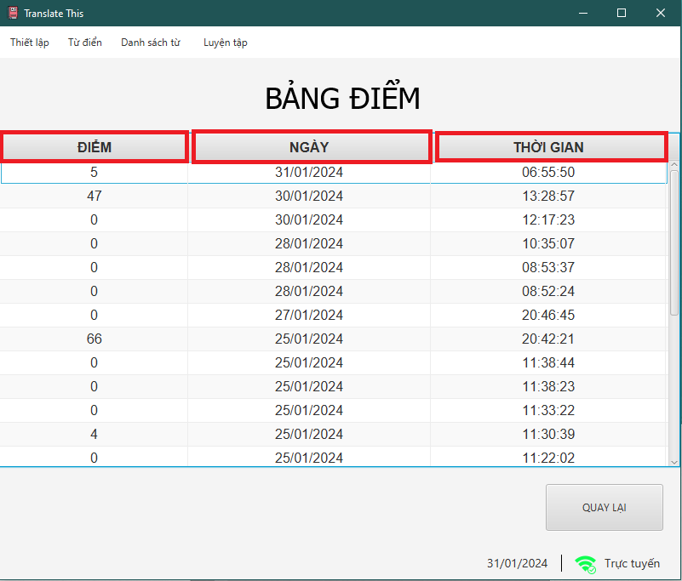

1. “Quay lại” button

When the "Return to game" button is clicked, the application navigates back to the detailed summary page

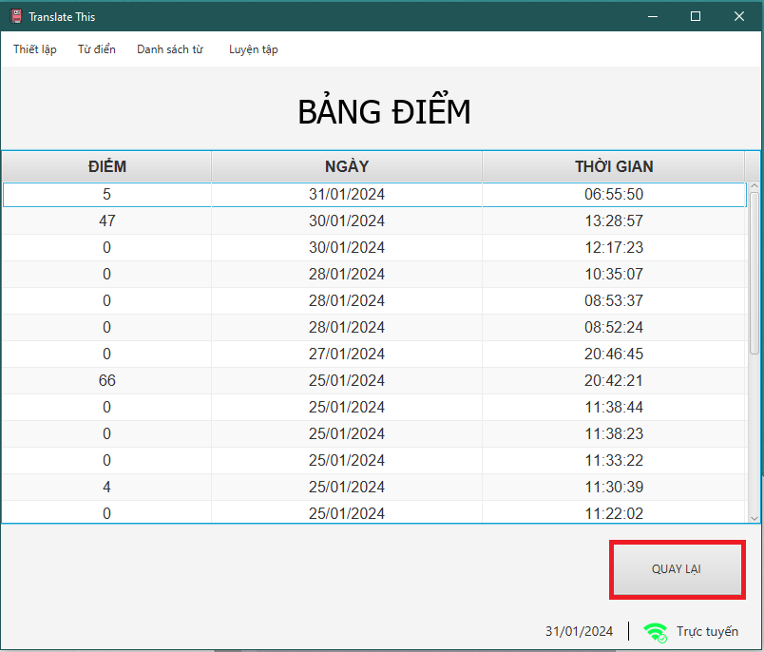

## **BẢNG XẾP HẠNG**

The summary page is designed to display the total score along with the date and time when the game session was played.

1. Filter table

The "Filter table" feature allows users to apply specific criteria to sort or narrow down the data displayed in a table. This can include options like filtering by score range, date, player name, or other relevant categories, making it easier to find and analyze specific data points within the table.

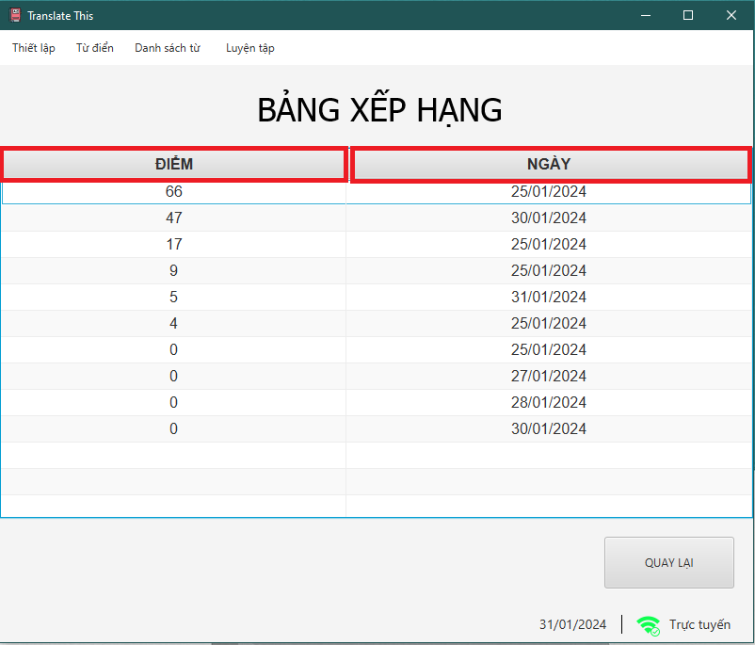

1. “Quay lại” button

When the "Return to game" button is clicked, the application navigates back to the detailed summary page

